Title of Manuscript
First Author¹, Second Author^{2*}, Third Author³, Fourth Author¹, Fifth Author^{2,3}
¹Department, Faculty/Institute/College, University, Postcode City, State, Country
²Centre of Foundation Studies, Universiti Teknologi MARA, Cawangan Selangor, Kampus Dengkil, 43800 Dengkil, Selangor, Malaysia
³Department of Mathematics, College of Science, Mustansiriyah University, Baghdad, Iraqi (Please check your affiliation with your instituitaion/organisation)
*Corresponding author: xxx@university.edu

ABSTRACT

These instructions give you guidelines for preparing full manuscript for International Conference on Research and Practices in Science, Technology and Social Sciences (I-Crest). Use this document as a template if you are using Microsoft Word 2001 or later for Windows, or Word X or later for Mac OS X. Otherwise, use this document as an instruction set. The title of paper should be 16 font Times New Roman, capitalize each word, bold and centred. It is preferable that the title is not more than 15 words. The author’s full name should be bolded, 12 font Times New Roman, capitalize each word and centred. Use 10 font Times New Roman, italic and centred for the author’s affiliation (capitalize each word). The corresponding author should have * symbol, email, italic and centred. The abstract heading should be 11 font Times New Roman, uppercase, and centred. The should not more than 300 words, 12 font Times New Roman, and Justify Text. The abstract should have problem statement(s)/issue, research objective(s), methodology/theoretical framework, summary of major findings, and conclusions. The abstract should not contain any undefined abbreviations or unspecified references. All manuscripts must be in English, printed in black ink. Leave one blank line before Keywords.

Keywords: Keyword 1; Keyword 2; Keyword 3 (Minimum 3 keywords and Maximum 5 keywords, typed using 12 font Times New Roman, two blank lines before the main text)

1. INTRODUCTION

These guidelines include complete descriptions of the fonts, spacing, and related information for producing your final full manuscripts to be considered in either a proceeding or a journal publication. Please read and adhere to the formatting instructions. Authors are recommended to use this template file to prepare your manuscript, you can simply type your own text over sections of this document or cut/copy and paste from another document. Do not select your title and author information as the document spacing may be affected. It is a simple task to re-enter your title and author information in this template. Place your cursor in the text area of the template and select Paste Special. Then, select “unformatted text”.
Authors must make sure that the research problems are well defined in the introduction. The objective must be clearly stated, measurable/assessable, and can be met by the research methodology/design used. Review of related literature must be relevant to the research issue(s), comprehensive and well-reviewed, organised, and summarised.

2. PAPER FORMATTING

The font size of headings should be 12 font Times New Roman, bold, and upper-case letters. There should be a single spacing between the first paragraph of a text and heading. Authors are requested to submit the full manuscripts of 7 to 8 pages in length in electronic form of MS-Word via our online submission page. The manuscript should be A4 page sized (21 x 29.7 cm or 8 x 11 in) with 3 cm margins top and bottom, 2.5 cm margins left and right. Do not write or print anything outside the print area. Please avoid using page numbers, headers, and footers. The text must be left and right justified.
The first paragraph in each section should not be indented, but all following paragraphs within the section should be indented (1 cm) as these paragraphs demonstrate. A single spacing should be left in between paragraphs. Figure and table must be centered. Graphics may be full color. Figures and tables must be numbered, and captions must be in 11 font Times New Roman and centered. Captions with figure numbers must be placed after their associated figures, as shown in Fig. 1. Supply the best quality figures possible. Captions with table numbers must be placed before their associated tables, as shown in Table 1. All figures and tables must be referred to in the main body of the text.

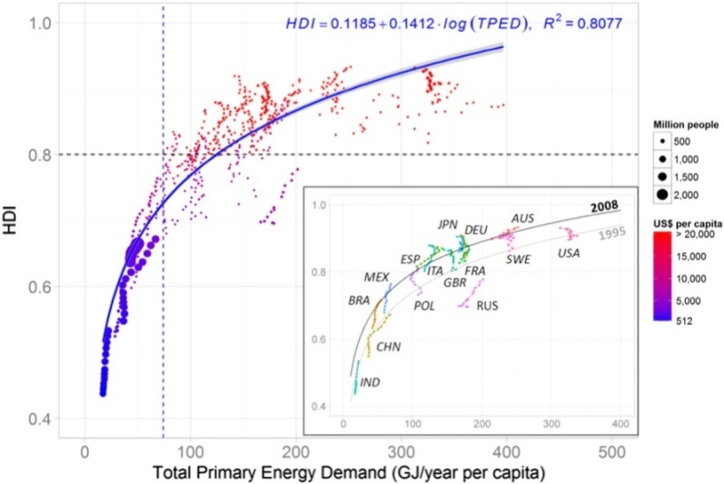

Fig. 1. Human development index, total primary energy demand per capita and GDP per capita of selected countries, 1995-2008 [9]
Table 1. Sample of table
No. | Body
1 | xxx

The paragraph after figure or table should be indented (1 cm). Equations can be created using the built-in Microsoft Equation editor. Equations should be labelled as follows: (1), (2) … ($n$). It is recommended to include a space above and below the equation respectively to segregate it from the text. The equations must be numbered sequentially, with the numbers placed in parentheses at the right-hand edge of the texts.

 | $x^{2}+y^{2}=r^{2}$ | (1)

2.1 Subsections/Second-Level Headings

Subsections/Second-level headings (if any) are typed in boldface with capitalised first letter(s). There should be a single spacing before and after subsections.

2.1.1 Subsubsections/Third-level eadings

Subsubsections/Third-level headings, as in this paragraph, are discouraged. However, if you must use them, they should appear in lower case (initial word capitalised). There should be a single spacing before and after Subsubsections.

3. CONCLUSION

Before submitting the manuscript, please check its composition and arrangement against the manuscript guidelines to make sure it includes and follows the required sections (introduction, literature review, methodology, result and discussion and study implications, study limitations and suggestion for future research) and stylizations. Failure to adhere to the manuscript guidelines may cause rejection without further review.
The conclusion should answer the research objectives. In specific, it should include the following: (1) the principles and generalisations inferred from the results; (2) any perceptions, problems, or limitations of the work; (3) theoretical and/or implications of the work; and (4) recommendations for future work.
List and number all bibliographical references at the end of the paper. The reference section should be made based on the IEEE referencing format. IEEE in-text citation consist of numbers provided in square bracket, which correspond to the appropriate sources in the reference list at the end of the paper. It is advisable that authors employ citation software such as Endnote or Mendeley. The in-text citations numbers start at [1] and continue in ascending order throughout the paper – unless you are referring to a source you have already cited in your text, in which case you can use the previously assigned number.
For example, Thevenin’s and Norton’s theorems are widely used for circuit analysis simplification [1]. As shown by Zaid [2][3], text text text. For more details, see [1], [3], [7]. As mentioned earlier [3], [4] – [6], [8]. Aini et al. [9] have noted that text text text.

ACKNOWLEDGEMENT

The authors can add in the acknowledgement to express their appreciation for the support of the sponsors. This should include details such as Project No, individual(s), or name(s) of organisation/institution. For example, the authors wish to thank A, B, C. This work was supported in part by a grant from XYZ.

REFERENCES

The reference list contains full details of all sources cited in-text. Reference list entries should appear in the order of the sources are cited in text of the paper, beginning with [1], and continuing on the ascending order, from the lowest number to the highest. References should be listed according to the latest IEEE style with numbering. Examples are as follows:

[1] A. Author and B. Author, “Title of article,” Journal Title, vol x, no. x, pp. xxx-xxx, 20xx
[2] F. L. Schmidt, and I.-S. Oh, “The crisis of confidence in research findings in psychology: Is lack of replication the real problem? Or is it something else?”Archives of Scientific Psychology, vol. 4, no. 1, pp.32–37.
[3] J. D. Bellamy et al., Computer Telephony Integration. New York: Wiley, 2010.
[4] H. H. Gaynor, Leading and Managing Engineering and Technology, Book 2: Developing Managers and Leaders. IEEE-USA, 2011. Accessed: Oct. 15, 2016. [Online]. Available: http://www.ieeeusa.org/communications/ebooks/files/sep14/n2n802/Leading-and-Managing-Engineering-and-Technology-Book-2.pdf
[5] M. T. Long, "On the statistical correlation between the heave, pitch and roll motion of road transport vehicles," M.S. thesis, College of Eng. and Sc., Victoria Univ., Melbourne, Mar. 2016. [Online]. Available: http://vuir.vu.edu.au/32281/1/LONG%20Michael%20-%20Thesis.pdf
[6] C. Wang, C. Wang, C. Xu, and D. Tao, “Tag disentangled generative adversarial network for object image re-rendering,” in Proceedings of the Twenty-Sixth International Joint Conference on Artificial Intelligence (IJCAI), 2017, pp. 2901–2907.
[7] W. M. Rohsenow, "Heat transmission," in Thermal Radiation Properties, vol. 3, M. W. Catton and J. P. Hartnett, Eds. New York: Macmillan, 2012, ch. 9, pp. 37–62.
[8] I. Arto, I. Capellán-Pérez, R. Lago, G. Bueno and R. Bermejo, “The energy requirements of a developed world”. Energy for Sustainable Development, vol. 33, pp.1-13.

